MIT ART, DESIGN AND TECHNOLOGY UNIVERSITY
School of Computing · LY-IT-CORE

Order Management System
Spring Boot · JPA · Hibernate · REST API

Mann Dharsandiya
ADT23SOCB1530
Academic Year 2024 – 25

1. Overview

A RESTful web application built with Spring Boot that manages the full lifecycle of customers, products, and orders. The system implements layered architecture, JPA entity relationships, and custom query methods, serving as a practical demonstration of enterprise backend development patterns.

2. Technologies

Technology | Purpose
Java 21 | Core programming language
Spring Boot 3 | Application framework & embedded Tomcat
Spring Data JPA | Repository abstraction and query derivation
Hibernate | ORM engine — entity ↔ table mapping
H2 Database | In-memory relational database
Lombok | Boilerplate elimination (@Data, @Getter, @Setter)
Maven | Build tool and dependency management
Postman | REST API testing and verification

3. Architecture

Standard three-layer Spring MVC structure:
Layer | Classes | Responsibility
Controller | CustomerController, OrderController, ProductController | Route HTTP requests
Service | CustomerService, OrderService, ProductService | Business logic
Repository | CustomerRepository, OrderRepository, ProductRepository | Data access via JPA
Entity | Customer, Product, Orders | Database-mapped objects
DTO | CustomerDto | Data transfer / projection

4. Entity Design

Customer (table: SwiggyCustomers)

Field | Type | Constraint
customerId | Long | PK · Auto-generated
name | String | NOT NULL
email | String | UNIQUE
city | String | —
age | int | —
bankUserName | String | —
password | int | —

Product (table: product)

Field | Type | Constraint
productId | Long | PK · Auto-generated
productName | String | —
price | double | —
category | String | —
quantity | int | —

Orders (table: Orders)

Field | Type | Notes
orderId | Long | PK · Auto-generated
quantityOrdered | int | —
totalPrice | double | price × qty (computed in service)
customer | Customer | FK → SwiggyCustomers (@ManyToOne)
product | Product | FK → product (@ManyToOne)

Relationship

Customer  (1) | One-to-Many  @ManyToOne | Orders  (Many)
Many-to-One
@ManyToOne
Product
(1)

5. API Endpoints

Customer /customers

Method | Endpoint | Description
GET | /customers | Get all customers
GET | /customers/{id} | Get customer by ID
GET | /customers/email/{email} | Get by email
GET | /customers/city/{city} | Get by city
GET | /customers/age/{age} | Get where age > value
POST | /customers | Create customer
POST | /customers/list | Bulk create customers
PUT | /customers/{id} | Update customer
DELETE | /customers/{id} | Delete customer

Product /products

Method | Endpoint | Description
GET | /products | Get all products
GET | /products/{id} | Get product by ID
GET | /products/category/{cat} | Get by category
POST | /products | Add product
POST | /products/list | Bulk add products
PUT | /products/{id} | Update product
DELETE | /products/{id} | Delete product

Orders /orders

Method | Endpoint | Description
GET | /orders | Get all orders
POST | /orders/{custId}/{prodId}/{qty} | Place order · total = price × qty

6. API Testing — Postman Screenshots

All endpoints tested via Postman at http://localhost:8082. Responses verified 200 OK with correct JSON structure.

GET /customers

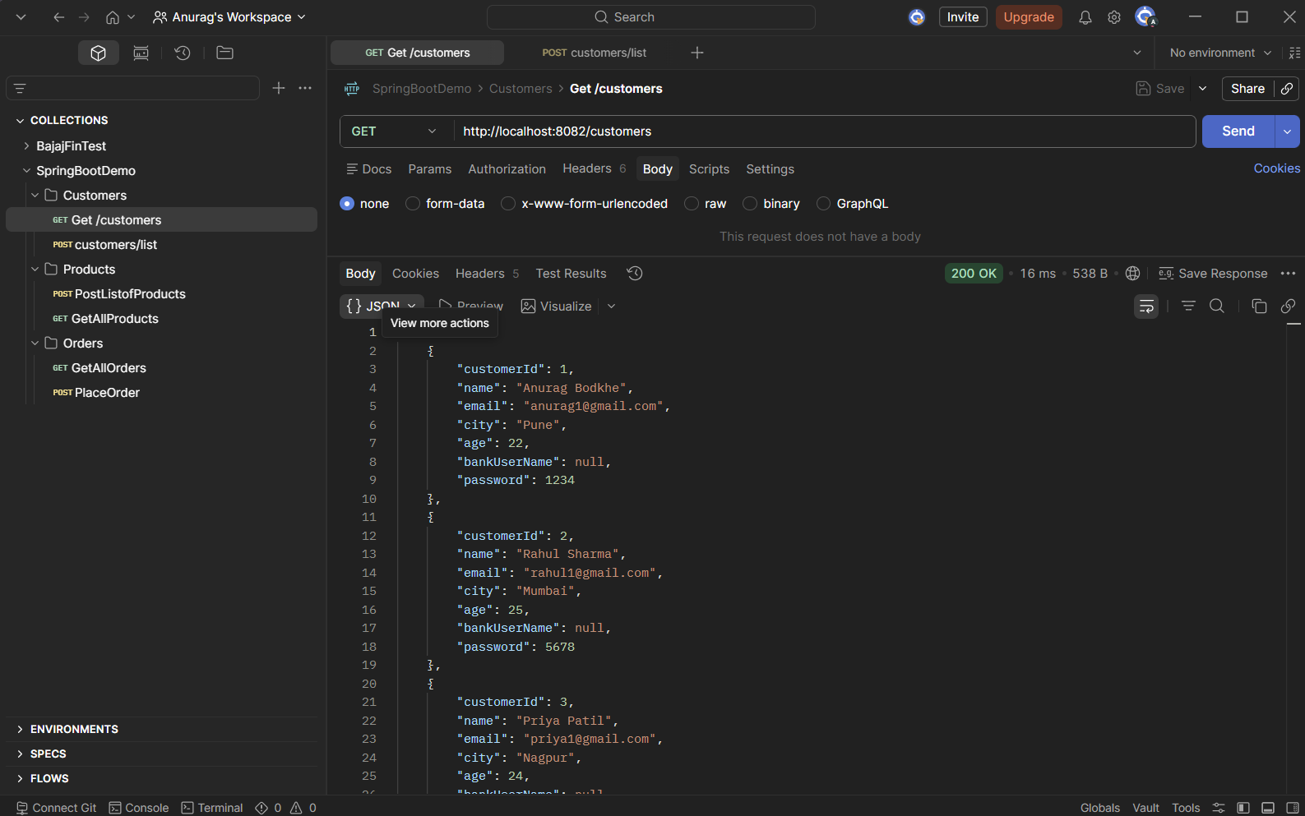
Figure 1 · GET /customers — returns all customer records (200 OK, 16ms)

GET /products
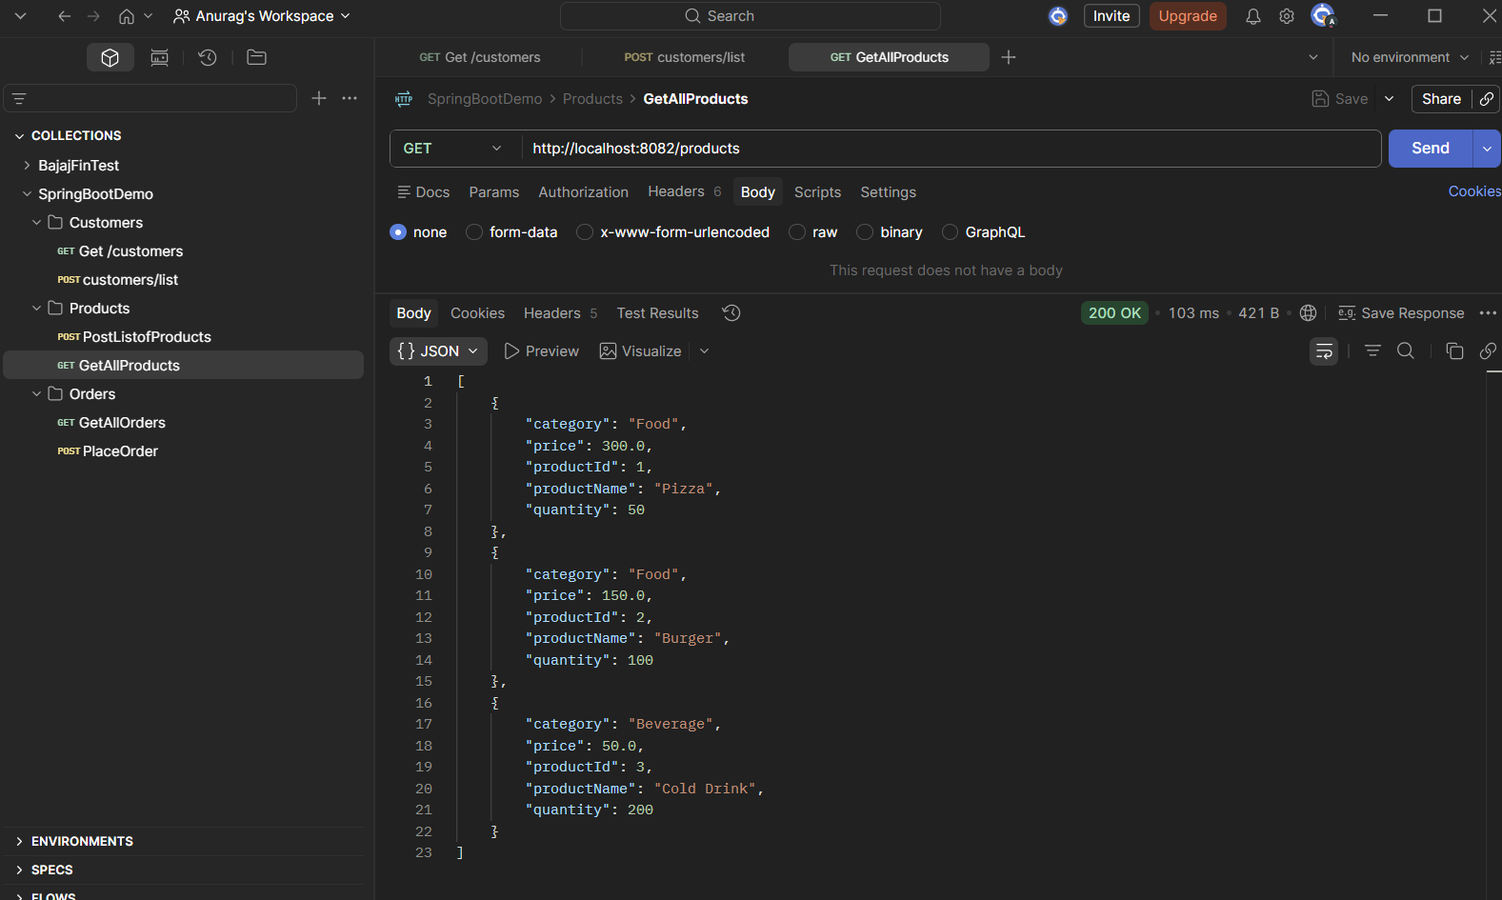
Figure 2 · GET /products — returns all product records (200 OK, 103ms)

GET /orders
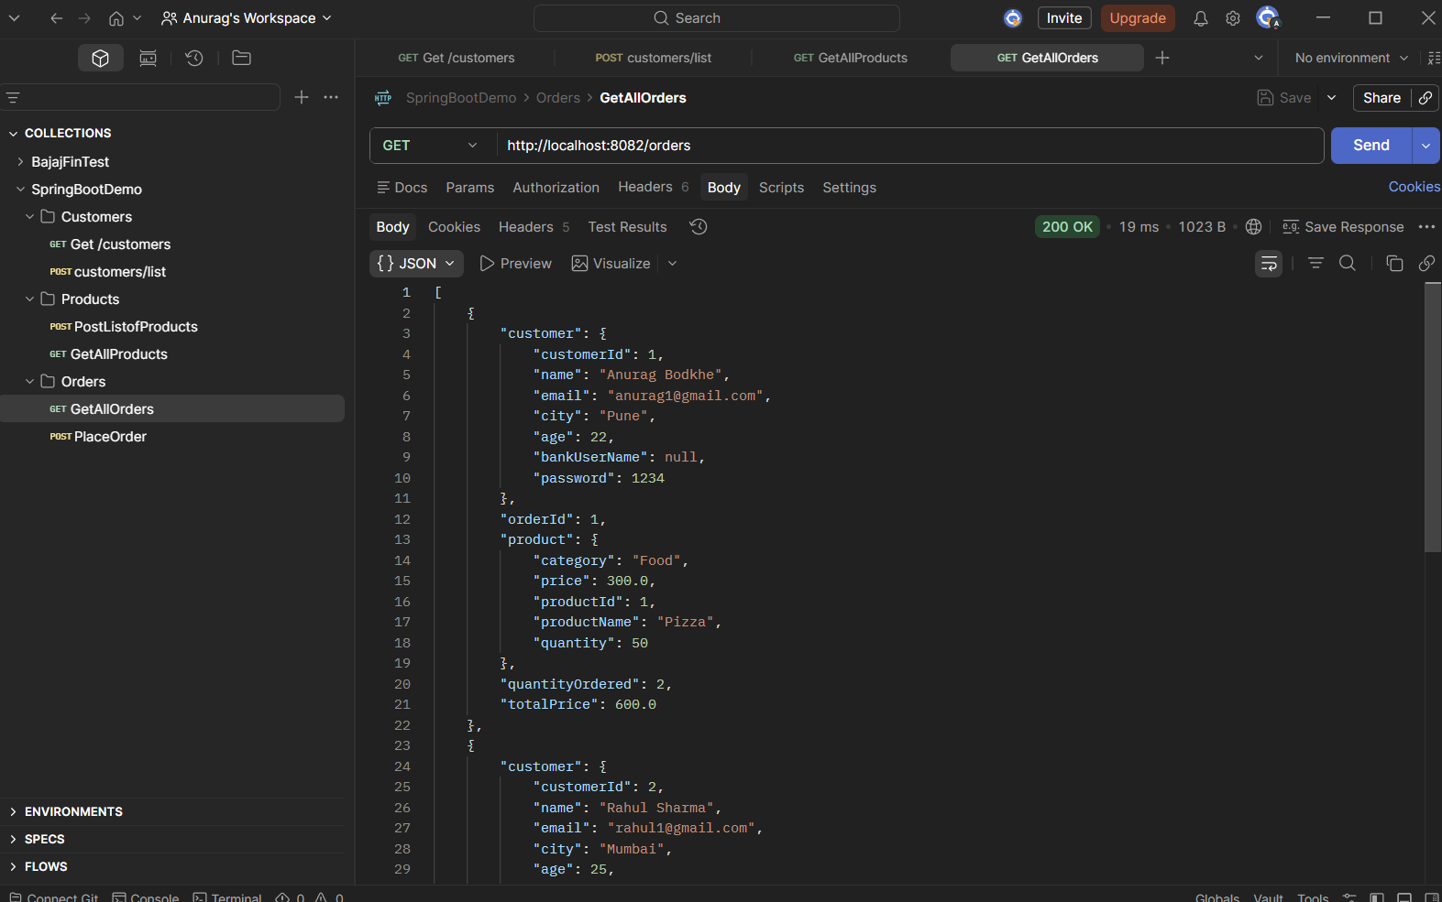
Figure 3 · GET /orders — returns full order objects with nested customer & product (200 OK, 19ms)

7. Database Verification — H2 Console

Data persistence verified using the H2 in-memory console at http://localhost:8082/h2-console.

SWIGGY_CUSTOMERS table

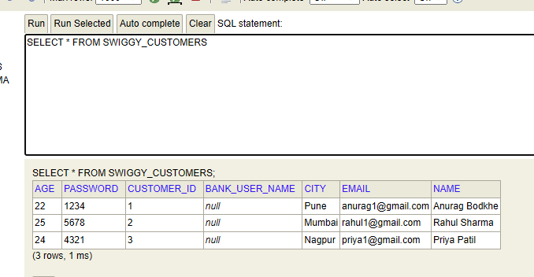
Figure 4 · SELECT * FROM SWIGGY_CUSTOMERS — 3 rows persisted

PRODUCT table

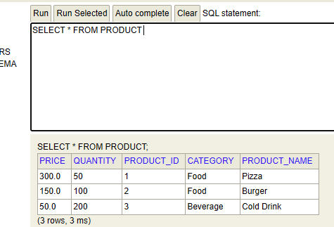
Figure 5 · SELECT * FROM PRODUCT — 3 products confirmed

ORDERS table

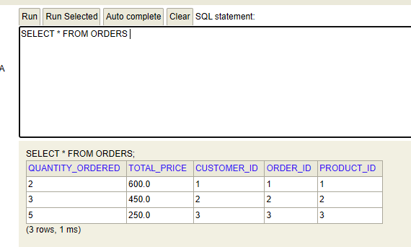
Figure 6 · SELECT * FROM ORDERS — foreign keys and totals verified

8. Repository — Custom Queries

Method | Repository | Type
findByEmail(email) | CustomerRepository | Derived query
findByCity(city) | CustomerRepository | Derived query
findByAgeGreaterThan(age) | CustomerRepository | Derived query
findByCategory(category) | ProductRepository | Derived query
countOrder(customerId) | OrderRepository | @Query — JPQL
totalAmount(customerId) | OrderRepository | @Query — JPQL
totalRevenue() | OrderRepository | @Query — JPQL

9. Conclusion

The Swiggy Order Management System demonstrates a complete Spring Boot backend stack:
- Layered architecture with clean separation of Controller, Service, and Repository
- @ManyToOne JPA mappings maintaining relational integrity across three entities
- Mix of derived query methods and JPQL @Query for flexible data access
- Business logic (total price computation) contained in the service layer
- All endpoints verified with Postman; data confirmed via H2 console queries

Mann Dharsandiya · ADT23SOCB1530 · LY-IT-CORE
MIT Art, Design and Technology University, Pune · 2024–25

